**Figure 1.**

**Figure 2.**

**Figure 3. REVIGO visualization of GO Cellular Component terms significantly associated with mtDNA-CN after removal of redundant GO terms. Size of the circle represents the relative number of genes in each gene set, color represents significance. Axis represent semantic similarities between GO terms; GO terms that are more similar will cluster with one another.**

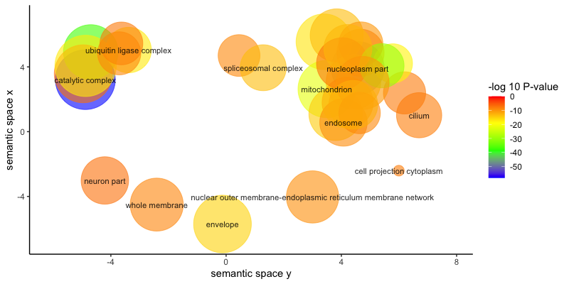

**Figure 4.**

**Figure 5.**

**Table 3. Linear regression effect estimates, standard errors, and p-values for transcription factors whose targets were significantly associated with blood-derived mtDNA-CN.**

|  | **Gene** | **Effect estimate   (gene expression)** | **Standard error   (gene expression)** | **P-value   (gene expression)** | **P-value   (enriched target sequences)** |
| --- | --- | --- | --- | --- | --- |
|  | NRF1 | 2.77e-02 | 1.52e-02 | 0.068 | 1.76e-35 |
|  | YY1 | 6.57e-02 | 1.35e-02 | 1.78e-06 | 3.14e-19 |
|  | GABPB2 | 9.40e-02 | 1.52e-02 | 1.51e-09 | 3.54e-21 |
|  | GABPB1 | 2.76e-02 | 1.39e-02 | 0.048 | 3.54e-21 |
|  | E4F1 | 5.27e-02 | 1.41e-02 | 2.01e-04 | 3.98e-15 |
|  | ELK1 | 3.80e-02 | 1.64e-02 | 0.021 | 8.58e-66 |

**Table 6. Test statistics from Cox proportional-hazards models examining the association between mtDNA-CN and incident neurodegenerative disease in the UKBiobank.**

|  | **Disease** | **Hazard ratio** | **Confidence interval** | **Number of cases** | **P-value** |
| --- | --- | --- | --- | --- | --- |
|  | Parkinson's disease | 0.75 | 0.60;0.99 | 63/39,044 | 0.0305 |
|  | Alzheimer's disease | 0.59 | 0.44;0.81 | 41/39,100 | 0.001 |
|  | Dementia (excluding AD) | 0.81 | 0.65,1.02 | 74/39,048 | 0.0742 |
|  | Combined neurodegenerative disease | 0.73 | 0.66;0.90 | 161/39,030 | 1e-04 |